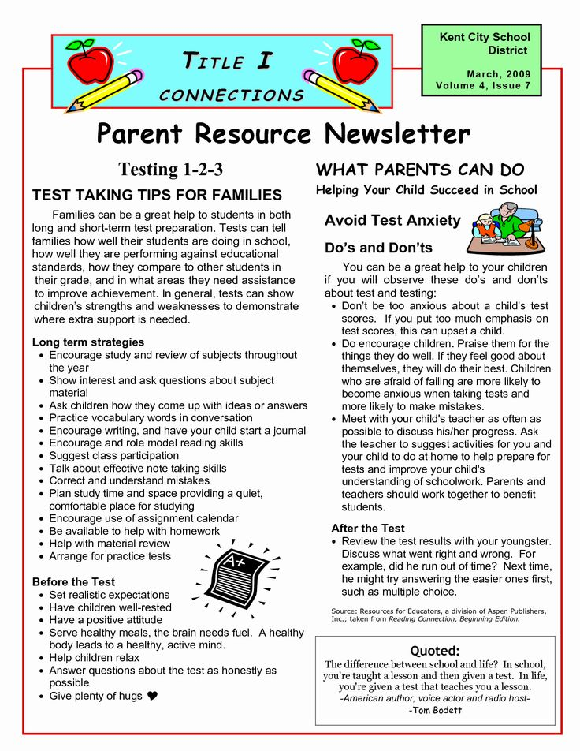

**Memphis Shelby County Schools**

**Raleigh Egypt Middle School**

**901) 416-4141**